National Audit Office
2014-2015
President:

Lidia Roumenova
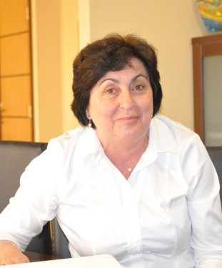
Born on 27 November, 1953.
She graduated in Law at “St. Kliment Ohridski” Sofia University. Later she acquired qualification in European Union Law, under a joint programme of “St. Kliment Ohridski” Sofia University with University Nansi 2 – France and Robert Schuman University, Strasbourg.
Ms Roumenova has experience in the field of civil, labour and criminal law, management and development of human resources, statute of foreign persons, taxes. She has actively participated in the development of a number of legal acts. Also she has experience in the field of external audit, foreign investments projects and in the communications field.
Since 1978 Ms Roumenova has held the position legal adviser in various structures: the foreign trade system, the National Committee of the Bulgarian Women, the Ministry of Labour and Social Care, the Ministry of Defense and the Radio Telecommunications Company Mobikom.
1981 -1986 Prosecutor in the Prosecutor’s Office of the Republic of Bulgaria
1986 - 1987 Expert at the Council of Ministers
2005 - 2009 Adviser to the Prime – Minister of the Republic of Bulgaria
May 2009 - January 2011 – Member of the National Audit Office
1997 – 2012 - Senior partner in INTEGRA Consultancy Services Ltd
Lawyer – Member of Sofia Bar Association
During her professional development, Ms Roumenova has acquired different certificates: Methods and evaluation of enterprises, under PHARE Programme; ISO 9000 for quality management system, health and safety working conditions and environment; OHSAS; “Legal actions and proceedings before the European Courts”, Luxembourg, 2008. She is certified expert for evaluation and accreditation of health centres.
Ms Roumenova has been manager and consultant in different EU projects for development of administrative structures, prevention and fight against corruption.
She speaks English and Russian.
Married, with two children
The National Assembly elected Ms Lidia Roumenova President of the National Audit Office of the Republic of Bulgaria on April 30, 2014.

Members:
Dileta Kasabova – Tokatliyan
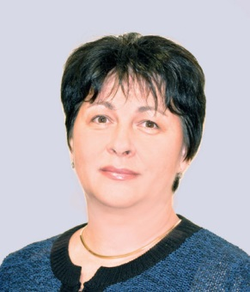
She graduated in “Economy and Management of Industry”, University of National and World Economy”, Sofia.
Before starting her career in the National Audit Office, till 1996, she has worked in Metallurgical Plant “Kremikovtzi”, Research University in Ferrous Metallurgy as research associate and in the private sector.
Ms Tokaltiyan teaches economy and organization of the chemical and metallurgical manufacture at the “Institute of Chemical Technologies”, Sofia.
Since 1996 she works at the National Audit Office of the Republic of Bulgaria, respectively as auditor, senior auditor, chief auditor and head of department within the Specific Audits Directorate.
She has more than 17 years experience in the field of external audit, mainly related to: concessions, government and municipal debt, international contracts for funding different projects with government and government-guaranteed loans, government and municipal privatization, Bulgarian National Bank, trading partnerships with state participation, state-owned enterprises. She has performed quality control, as well as audits pursuant to the Political Parties Act and the Election Code.
Since 2002 she has participated in the activity of the INTOSAI Working Group on Audit of Privatization, economic regulations and public-private partnerships.
Certified internal auditor in the public sector.
She speaks English and Russian.
The National Assembly elected Dileta Kasabova – Tokatliyan Member of the National Audit Office of the Republic of Bulgaria on June 11, 2014.
--
Assoc. Prof. Dr. Evgenia Penkova - Pantaleeva
Born on 6 February in Haskovo, Bulgaria.
She graduated in “Finance and credit” from the University of National and World Economy /UNWE/, Sofia.
Since 1986 she is a lecturer in the “Management of the Social Activities” Department in the UNWE.
In the period 2000 - 2005 she has been successively head and vice-dean of the “Infrastructure Economy Department” in UNWE.
She specialized in Germany, Russia, Greece, Hungary, UK and Netherlands. She participated in 16 international programmes and projects under PHARE, TEMPUS, Leonardo da Vinci, MATRA,OPAC and projects co-financed by the European Social Fund.
2002-April 2005- President of the Post-Privatization Control Agency.
13 April 2005-26 January 2011 – Member of the National Audit Office, Head of Department
Since 26 January 2011 she is associate professor at the UNWE, “Public Administration Department” and reads lectures in “Local Finances and Administration” and ” Welfare Economy”.
Author of a more than 30 scientific publications in the field of public finance.
She speaks Russian and English.
The National Assembly elected Ms Evgenia Penkova-Pantaleeva Member of the National Audit Office of the Republic of Bulgaria on June 11, 2014.
Goritza Grancharova
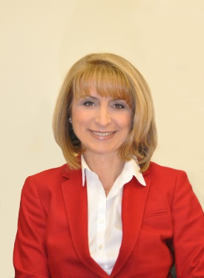
Born on 9 April in Razlog, Bulgaria.
She graduated in “Accountancy and control”, “D.A. Tsenov” Academy of Svishtov .
She has a long professional experience in the field of banking and finance.
From 2000 to April 2004 - Manager in the "Economic and Investment Bank",Ltd – “NRA” Office. She worked as accountant in State Insurance Institute (DZI) – Razlog, branch manager TS Bank Ltd –Bansko and as deputy chief accountant in "Bulgargas", Sofia.
In the period May 2004 - April 2005 she is chief expert in the National Revenue Agency.
13 April 2005-26 January 2011 – Member of the National Audit Office, Head of Department.
Within the scope of Department II, headed by Ms Goritza Grancharova, fell the following auditees: Ministry of Defence, Ministry of Environment and Water, National Statistical Institute, Commission for Personal Data Protection, Council for Electronic Media, Bulgarian National Radio, Bulgarian National Television, and Bulgarian Export Insurance Agency. Coordinator from the National Audit Office with the International Board of Auditors for NATO. Also, she participated in a number of projects for cooperation between the Bulgarian SAI and EUROSAI.
Since 7 April 2011 she is appointed Member of the Consultative Council to the National Audit Office of the Republic of Bulgaria.
The National Assembly elected Ms GoritzaGrancharova Member of the National Audit Office of the Republic of Bulgaria on June 11, 2014.

Mustafa Zankov
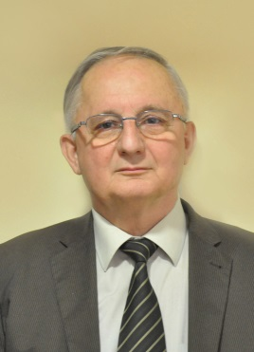
Born on 13 April 1941 in Svishtov, Bulgaria.
He graduated in “Accountancy”, “D.A. Tsenov Academy of Svishtov”.
Since 1966 he has held the position chief accountant in a number of state-owned and commercial enterprises in Svishtov: State-owned enterprise “Zarneni Hrani” and Chemical Plant “Sviloza”.
In the period 1977 – 1989 – he worked as chief accountant successively in: Installation Management for Construction of a Heavy Machine Building Plant, Radomir; Holding Company “Pharmacy” and IBH “Verila”.
1989 – 1990 – Deputy Director “Scrap Factory “
1990-1992 – Chief accountant “Trading Partnership” Ltd., Sofia Municipality
1992 – 1995 – Member of the Supervisory Board of the Privatization Agency at the Council of Ministers.
2003-2006 – Director “Financial Activities and Property Management Directorate”, Agency for Child Protection at the Council of Ministers.
2006-2012 – Director “Financial Activities and Property Management Directorate”, Commission for Protection against Discrimination.
Since 2012 he is chief accountant at the National Institute for Conciliation and Arbitration to the Ministry of Labour and Social Policy.
He speaks Turkish and French.
The National Assembly elected Mustafa Zankov Member of the National Audit Office of the Republic of Bulgaria on June 11, 2014.
Shirin Ismail
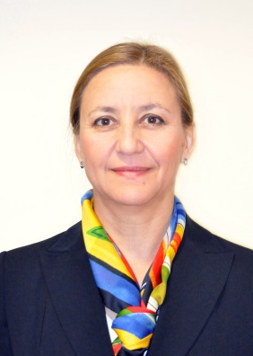
Born on 13 May, Ardino, Bulgaria
She graduated in “Finance and Credits”, D. A. Tsenov, Academy of Svishtov.
1988 - 1992 г.- Chief Accountant in the Municipal Council, Ardino.
1992 - 2000 – Head of Tax Office, Ardino.
2000 - 2006 – Tax Expert, Regional Tax Directorate, Sofia.
2006-2010 – Senior revenue expert, National Revenue Agency.
In 2007 she acquired certificate for internal auditor in the public sector.
2011 - 2012 – Financial inspector, Sofia Municipality, Lozenetz Area.
2012 – Senior internal auditor, Internal Audit Unit, Ministry of Education and Science.
She speaks English, Russian and Turkish.
The National Assembly elected Shirin Ismail Member of the National Audit Office of the Republic of Bulgaria on June 11, 2014.
Stefka Mihaylova
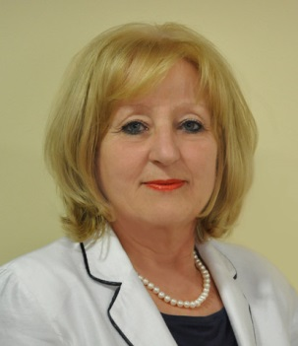
Born on 22 September, Haskovo, Bulgaria.
She graduated in “Economy and Organization of Agriculture”, University of National and World Economy”, Sofia.
1977-1994 – Research specialist in “Economic Analysis and Prognosis Department”, Institute of Economics to the Bulgarian Academy of Science.
1994 - 1996 г. –Manager “Marketing and Sales Department” TMT “Invest”, Ltd.
1996 – 1999 – Head of “Privatization Department”, Gasstroymontaj, JSC.
Since 19th May 1999 she works at the National Audit Office of the Republic of Bulgaria, respectively on the positions: auditor, senior auditor and chief auditor. Her experience is in the field of: analysis and evaluation of financial and non-financial information; Formulation of audit questions related to the implementation of the audit task and preparation of the audit programme; Formulation of recommendations and conclusions for the implementation of the audit task; Formulation of audit statements in relation to the analysis and evaluation of the information in the Annual financial statement; Preparation of audit reports and draft recommendations; Preparation of drafts conclusions to the head of department.
Since 2002 she has an international certificate for auditor-trainer, issued by the INTOSAI Development Initiative (IDI).
She speaks English and Russian.
The National Assembly elected Stefka Mihailova Member of the Board of the National Audit Office of the Republic of Bulgaria on June 11, 2014.
Toma Donchev, PhD
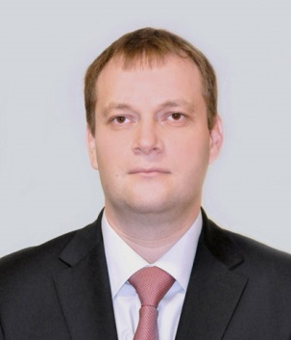
Born on 14 April 1979 in Karlovo, Bulgaria.
He graduated in “Accountancy and Control” and “International Economic Relations”, University of National and World Economy, Sofia.
He has doctoral degree in “Accountancy, Control and Analysis of Economic Activity”, and dissertation on “Control over the effective use of EU funds in situation of expanded decentralized management”.
Since 2009 he is registered auditor, chartered accountant.
Since 2011 he is chief assistant in Financial Control Department, Financial Accounting Faculty at the University of National and World Economy where he teaches in the following majors: “Auditing”, “Audit of EU Funds”, “Systems for managerial control” “Performance audit”, “Financial management and control systems”.
2006-2011 – Part-time lecturer to “Financial Control” Department
January 2013 - June 2014 - Owner and manager of “Ace Audit” Ltd, with object of a business accountancy, audit and business consultations.
January 2001 - January 2013 - Chief accountant and auditor in “Accountancy and Audit House Expert M Ltd.
In the period 2003 - 2004 - Consultant to GTZ GmbH, Germany, under a project “Improvement management and absorption of EU funds. Development of a practical manual and procedures for improvement of the effectiveness and efficiency of expenditure in public sector at all managerial levels, providing recommendations regarding delegation of responsibilities, analysis of the process for planning and allocation of budgets, strategies for budget systems improvement; internal control, financial control, monitoring and evaluation.
He speaks English.
The National Assembly elected Toma Donchev, Member of the National Audit Office of the Republic of Bulgaria on June 11, 2014.
Zlatina Ruseva
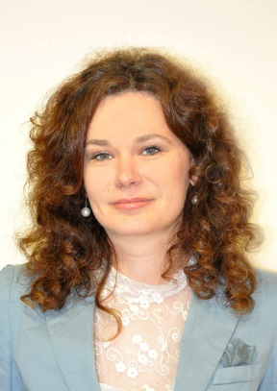
Born on 9 July in Tryavna, Bulgaria.
She graduated in Law from the “St. Cyril and St. Methodius” “University of Veliko Tarnovo.
January 2000 – November 2004 – Legal adviser and Head of “Legal Services Department”, State Agency for Standardization.
December 2004 – May 2005 – Legal adviser in “Overgas Ink”, Ltd.
In the period May 2005 – March 2011 she is Director, “Legal Services Directorate” at the National Audit Office of the Republic of Bulgaria. Her responsibilities were related to: provision of overall legal services; participation in the preparation of the common audit methodology in the field of audit of internal control systems; public procurements, infrastructural projects; public-private partnerships. Also she was in charge of the preparation of the following documentation: legal opinions, contracts, drafts of regulatory acts, internal rules, instructions and procedures; correspondence with the National Assembly, state and territorial bodies, and audited entities. In addition to the methodological functions assigned, she has exercised quality control on audit reports, as well as preparation of the Audit Manual.
Leader and coordinator of a number of international projects and activities conducted by the National Audit Office.
March 2011 – July 2011 – Senior collaborator in the mananagement of EU projects and programmes at the Council of Ministers of the Republic of Bulgaria.
July 2011 -September 2013 г. Chief legal adviser under “Nabucco” Project, “Nabucco Gas Pipeline Bulgaria”, Ltd
September 2013 – March 2014 – lawyer under “South Stream Gas Pipeline” Project in “South Stream Bulgaria”, Ltd.
She speaks English and Russian.
The National Assembly elected Zlatina Ruseva Member of the National Audit Office of the Republic of Bulgaria on June 11, 2014.

